Title: Dectin-1 binds the entrails of HDM.

Abstract:

Non-TLRs account for little of the research regarding HDM-induced allergic airway inflammation. One such receptor, Dectin-1, expressed on CD11b+ DCs, has emerged as important in the recognition of HDM-derived β-glucan, CCR7-mediated migration of DCs to draining lymph nodes, Th2 and Th17 differentiation, and recruitment of inflammatory cells to target tissues.

Word count: 50

Background:

There has been little research into the role of non-toll-like receptors (TLRs) and allergic airway inflammation, an example of which is asthma (Google scholar**)**. Recently, the non-TLRs Dectin-1 (gene symbol *Clec7a*) and Dectin-2 (gene symbol *Clec4n*) were found to be involved in house dust mite (HDM)-mediated allergic immunity associated with asthma (Gregory and Lloyd, 2011). They are pattern recognition receptors (PRRs) which do not rely on the HDM itself, but fungal species present in their gastrointestinal tract; β-glucan and α-mamman, respectively. Although previous studies on Dectin-1 presented conflicting conclusions, the presence of the Dectin-1 ligand β-glucan in HDM suggests the involvement of Dectin-1 in allergic airway inflammation.

Furthermore, Dectin-1 and Dectin-2 are known to induce Th17 cell differentiation though the mechanism underlying their induction is poorly understood (Saijo and Iwakura, 2011). Th17 cells are a subset of CD4+ T helper cells classified by their specific ability to produce IL-17. They have been associated with immune responses in infection and autoimmune diseases via the recruitment of neutrophils and macrophages to target tissues.

Indeed, neutrophilia is a feature of Th17 cell-mediated inflammatory diseases, an example of which is airway allergic inflammation in asthma (Locksley, 2010). Although asthma is categorised by the infiltration of eosinophils, in some cases there may also be increased neutrophils in the sputum. Therefore, it is likely that Th2 cells play an important role in this inflammatory disease.

In asthma, the allergen/antigen comes into contact with the mucosal lining of the lung where DCs engulf it for presentation to Th2 cells which produce IL-4 and IL-5 (Kumar et al., 2012). IL-4 acts on B cells to produce IgE antibody which activates mast cells that also produce IL-5 for the recruitment of eosinophils that release granules and mediators. Eosinophils increase vascular permeability resulting in oedema, while mast cells increase mucus production and recruit leukocytes from the blood. This all occurs within minutes of exposure. Hours later, the leukocytes arrive releasing more mediators that cause further damage and send recruitment signals again. The cycle continues.

Study summary:

Given that the presence of Th2 and Th17 cells is well-determined in inflammation, Ito et al. aimed to clarify whether these cell types were involved in the Dectin-1 pathway. Mediastinal lymph node (MLN) cells from HDM-sensitized and -challenged *Clec7a­-/-* and WT mice were stimulated with HDM and the presence of certain cytokines was measured by ELISA. Of interest, were the significantly reduced amounts of IL-5 IL-13, and IL-17, consistent with previous knowledge (Kumar et al., 2012).

On the other hand, while a previous study found that Dectin-1 was expressed on myeloid cells (Taylor et al., 2002), Ito et al. came across conflicting results in this regard. They observed Dectin-1 expression not on myeloid cells, but on the CD11b+ dendritic cell (DC) subset. This was realized using anti-Dectin-1 staining and flow cytometry. Furthermore, CD11b+ DCs were demonstrated to be involved in HDM-induced allergic airway inflammation since the numbers of eosinophils, neutrophils, and CD4+ T helper cells were reduced. Although these numbers did not all reach significance, a trend was observed overall. This suggests that other cells which express Dectin-1 could also be involved.

Furthermore, having found via qPCR that the levels of CCR7, a migratory cytokine, is significantly reduced in *Clec7a­-/-* mice, the study examined whether Dectin-1 was also involved in the migration of DCs upon HDM stimulation. This was achieved by sensitizing *Clec7a­-/-* and WT mice with unlabelled HDM, followed by fluorescent-labelled HDM. Lung and MLN cells were then analysed by flow cytometry. It was found that in *Clec7a­-/-* mice, there was a significant reduction in the number of CD11b+ DCs in the MLN that expressed CD80, CD86, and CCR7 compared to that of the lung. CD80 and CD86 are well known for their role in T cell differentiation (Chen et al., 2006), and CCR7 plays an important role in migration of DCs for subsequent maturation (Kumar et al., 2012).

Discussion:

HDM, the representative allergen for asthma, contains fungal cell wall components in its extract, and Dectin, a C-type lectin receptor, is known to recognise these components (Gregory and Lloyd, 2011). Although the two have been linked together in regards to allergic airway inflammation, the mechanism behind the disease progression has conflicting conclusions. This study aimed to clarify some of these conflictions and delve deeper into the role of Dectin-1 in HDM-induced airway inflammation.

Previously, Dectin-1 was shown to be irrelevant in airway hyperactivity to fungal antigens when pre-treated with anti-Dectin-1 antibody (Albacker et al., 2013). Alternatively, Ito et al. clearly demonstrated a relationship between HDM-induced airway inflammation in *Clec7a­-/-* mice where Th2 and Th17 cells, which are classically associated with inflammation (Kumar et al., 2012), were significantly reduced. The difference in results may be attributed to the differences in methodologies. The pretreatment step with HDM by Ito et al. could have resulted in enhanced Dectin-1 function which was observed as airway inflammation in what is referred to as trained innate immunity (Quintin et al., 2014). Clarification is needed to determine whether trained innate immunity is involved in HDM-induced allergic airway inflammation via Dectin-1.

A better understanding of Dectin-1 and its C-type receptor relative, Dectin-2 has wider implications in developing treatments for allergic airway inflammation since many of their components overlap (Saijo and Iwakura, 2011). Inhibition of these pathways could be an ideal therapeutic target for asthma, neutrophilic airway inflammation, and type I hypersensitivity involving fungal antigens.

Word count: 839

References:

Albacker, L. A., Chaudhary, V., Chang, Y. J., Kim, H. Y., Chuang, Y. T., Pichavant, M., DeKruyff, R. H., Savage, P. B., and Umetsu, D. T. (2013). Invariant natural killer T cells recognize a fungal glycosphingolipid that can induce airway hyperreactivity. *Nature Medicine*. **19**: 1297–1304.

Chen, Y. Q., and Shi., H. Z. (2006). CD28/CTLA-4–CD80/CD86 and ICOS–B7RP-1 costimulatory pathway in bronchial asthma. *Allergy.* **61**: 15–26.

Google scholar. (2017). “*TLR and asthma*”: 36,600 results. “*Non-TLR and asthma*”: 618 results. https://scholar.google.com.au. Accessed 18/9/17.

Gregory, L. G., and Lloyd, C. M. (2011). Orchestrating house dust mite-associated allergy in the lung. *Trends in Immunology.* **32**: 402-411.

Kumar, V., Abbas, A. K., and Aster, J. C. (2012), Robbins Basic Pathology. *Elsevier Health Sciences, Saint Louis.*

Locksley, R. M. (2010). Asthma and allergic inflammation. *Cell.* **140**: 777-783.

Quintin, J., Cheng, S., van der Meer, J. W. M., Netea, M. G. (2014). Innate immune memory: towards a better understanding of host defense mechanisms. *Current Opinion in Immunology.* **29**: 1-7.

Saijo, S., and Iwakura, Y. (2011). Dectin-1 and Dectin-2 in innate immunity against fungi. *International Immunology.* **23**: 467-472.

Taylor, P. R., Brown, G. D., Reid, D. M., Willment, J. A., Martinez-Pomares, L., Gordon., S. and Wong, S. Y. (2002). The beta-glucan receptor, dectin-1, is predominantly expressed on the surface of cells of the monocyte/macrophage and neutrophil lineages. *Journal of Immunology*. **169**: 3876–3882.

Summary figure and legend:

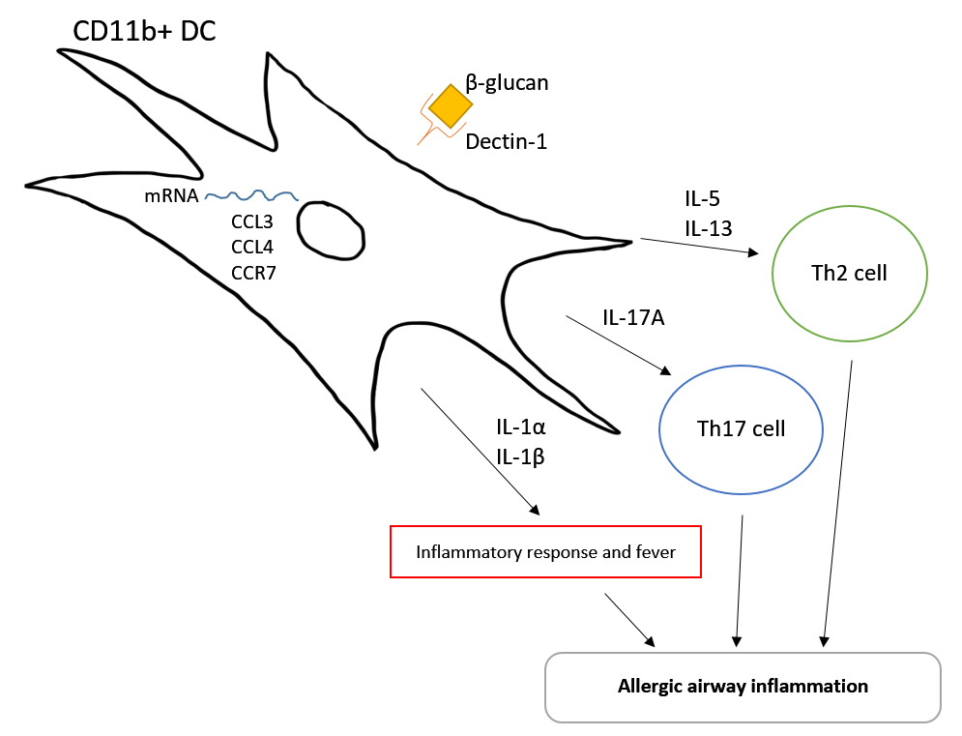

**Figure 1:** Dectin-1 (gene symbol *Clec7a*) is a C-type lectin receptor, a pattern recognition receptor (PRR), which recognizes the fungal cell wall component β-glucan. Decin-1 is present on the CD11b+ DC subset. When bound to its ligand, Dectin-1 drives the production of mRNA in the DCs, specifically CCL3 and CCL4 for activation of DCs, and CCR7 for migration of DCs. The CD11b+ DC also produces IL-5 and IL-13 for the development of Th2 cells, IL-17A for the development of Th17 cells, and IL-1α and IL-1β which induces an inflammatory response and fever. Altogether, these contribute to allergic airway inflammation through Dectin-1 activation on CD11b+ DCs.